
Reception Intake September 2025 Welcome to Woodgate

Prospective New Families,
I very much appreciate you considering Woodgate as the school for your child.
I know what a difficult decision it can be. We pride ourselves on being a caring school, putting the well-being of our school community at the very heart of our priorities.
Our staff and children would like to invite our prospective families around Woodgate so please join us on our open sessions.
I understand that many of you will have been looking at a variety of schools, reading up on them and talking to others who have children who already attend. However, it is no real substitute for visiting schools, feeling and hearing the ‘buzz’ and seeing the happy, hard-working children and meeting the staff team.

WHAT OFSTED HAD TO SAY … ‘The overwhelming majority of parents who spoke to inspectors agreed that they would recommend the school to another parent and that their child was happy in school and felt safe.’ June 2019

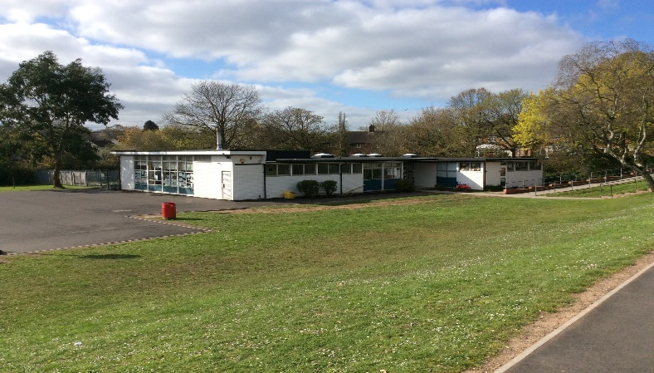
Reception classes are based in a lovely Annex building, situated in our superb school grounds which incorporates a large field, woodland, wildlife areas, a trim trail, mini golf course, pond and a memory garden. We have three classrooms in the annex where our children learn in warm, bright and well-resourced surroundings.
The Annex is secure with outdoor cameras and fob locked doors and an outdoor learning area enclosed by fencing.

In EYFS (Early Years Foundation Stage), we strive to nurture inquisitive minds, develop confidence through independence and most importantly, foster a love of learning as children make great steps in their personal, social and academic development throughout the Reception year.

The EYFS curriculum is skills based, and our competent staff creatively plan and support children to develop these skills and build knowledge through real life experiences. Learning experiences of the highest quality are planned, considering children’s needs and achievements and the range of activities that will help them make progress. The EYFS team also plan opportunities to explore children’s areas of interest through topics and engaging learning hooks such as investigating dinosaur bones, caring for chicks and watching them hatch and hosting a Teddy Bears’ Picnic.

WHAT OFSTED HAD TO SAY … ‘The quality of teaching, learning and assessment is good. Teachers provide well planned activities that enthuse the children and are carefully matched to their learning needs.’ June 2019

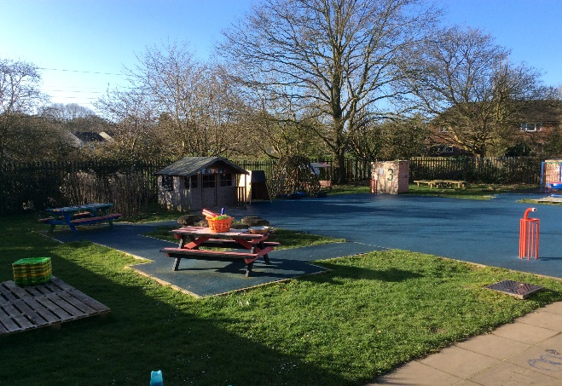
Within our daily learning, children choose to move freely between indoors and outdoors, having access to both our canopy and outdoor area. We welcome visitors from our local community, plan exciting experiences such as visits to the forest and enjoy sharing our learning with our families through parent/carer curriculum workshops and performance assemblies.

In Reception, one day is never quite the same as the next, however, there are some things that will happen every day. These include phonic sessions, adult-led activities, story times, child-initiated play and outdoor learning.

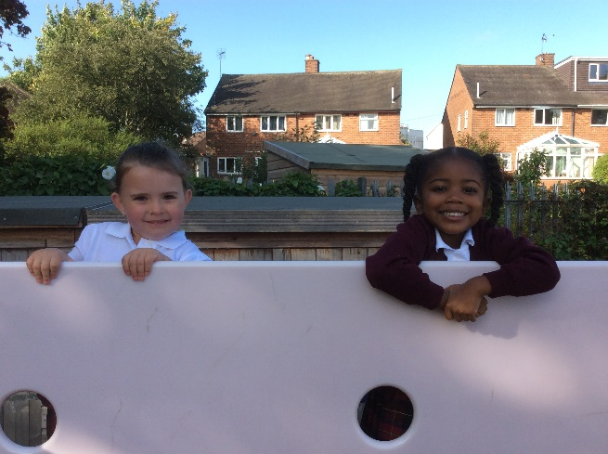

Adult-led play involves play opportunities set up by adults for children to discover and explore. Adult-initiated activities last for approximately 20 minutes. Your child will be expected to complete a number of adult-led activities throughout the week. They are taught through fun play-based activities which will include the teaching of Reading, Writing, Maths, as well as all the other areas of the EYFS curriculum.

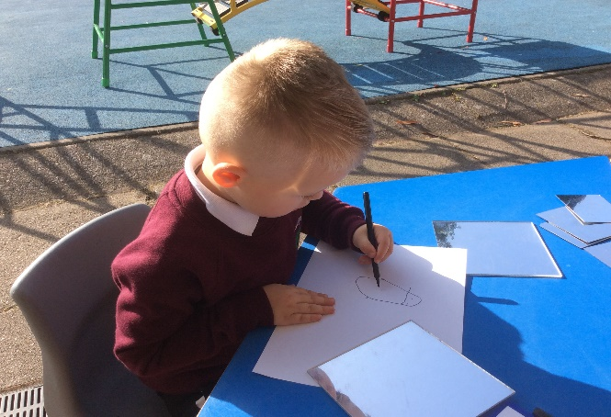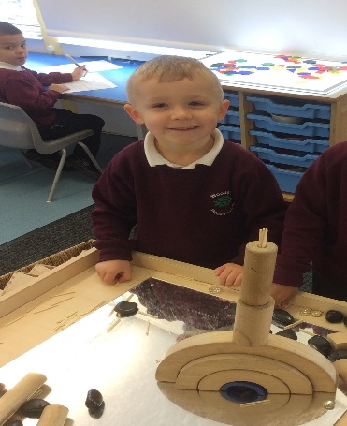
During child-initiated time, children will have access to a range of toys and equipment as well as further enhancements to support their learning. What they play with or do, who they play with and how they learn will be entirely up to them. During this time teaching staff will be facilitating, observing and recording evidence of children’s achievements.

Play is essential for children's development, building their confidence as they learn to explore, to think about problems, and relate to others. This enables the staff team to see how your child learns and then progress against the characteristics of learning which then informs planning and provision.

WHAT OFSTED HAD TO SAY … ‘Children are motivated and clearly enjoy coming to school. They behave well and listen to adults. They clearly understand expectations and some concentrate for long periods of time on tasks they plan for themselves, especially in the role play area.’ June 2019

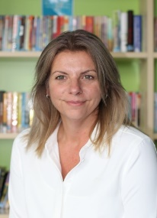
I, like other members of the team, have been part of the Woodgate family for many years and have taught in many different year groups. I have been in EYFS for the last ten years, leading the department and working with many outside agencies that support children and their families.
The staff team consists of a teacher and teaching assistant in each of the two classes. All members of the team foster positive relationships with all children and are sensitive and responsive to each child’s needs. The team are also supported by Miss Carroll, Assistant Head Teacher, who is responsible for SEND and Safeguarding. Miss Carroll supports the team, children and their families.
We are also supported by Mrs Green, a Speech and Language Therapist, and Miss Pearson, a teaching assistant who carries out speech and language interventions on a daily basis for those that need it. Our Sports Coach delivers a session of P.E. to the children once a week, supporting physical development and gross motor skills.

Miss Carroll

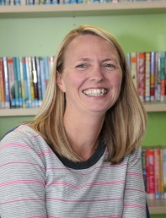
Mrs Green

WHAT OFSTED HAD TO SAY … ‘There are many well-planned opportunities to stimulate children to talk and develop their vocabulary. This is highly effective in supporting children’s academic, personal and social development.’ June 2019

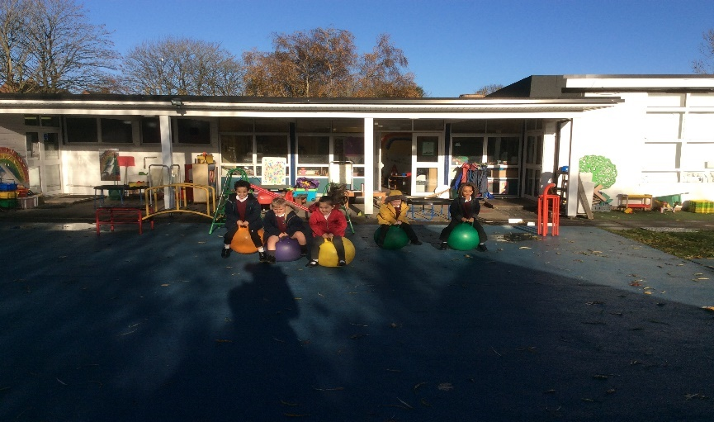

As part of the Woodgate school community, your child and your family will participate in many events, such as coffee mornings, charity days, sponsored walks, parents’ meetings and fun afternoons. There are book sheds for both children and adults to access a range of genres of books to share at home. You may keep the books or return them. If you have any to donate the service can reach more Woodgate families. We have close links to the local church of St Michael’s where we have services through the year such as the very popular Christingle service. The local food bank is based at St Michael’s church and Woodgate families often replenish its stock for families in the local community. The school council chooses a charity to support each year with fund raising activities throughout the year.

Throughout your child’s learning journey at Woodgate they will experience visitors bringing history to life, theatre company productions, learn a musical instrument, have swimming lessons, have the opportunity to join extra-curricular clubs and go on a residential visit in Year Six!

There are also many agencies that we work with to support our families. We employ a Psychotherapist, offer Malachi family support and various adult learning courses throughout the year.

WHAT OFSTED HAD TO SAY … ‘This is an extremely caring and nurturing school. The needs of pupils and their welfare are at the heart of all the school does.’ June 2019

I hope that this document and the rest of our website provides you with a ‘flavour’ of what life is like for children here at Woodgate. Our prospectus is available on the website https://www.woodgateprimary.co.uk/woodgate-prospectus. If you would like to receive a paper copy of our prospectus then please contact the office at enquiry@woodgate.bham.sch.uk Here is where you will find the most recent OFSTED report: https://www.woodgateprimary.co.uk/ofsted-reports.

However, if you would like to talk to a member of the senior leadership team to find out more then please do not hesitate to contact us either by email or call school on 0121 464 2315 and we can arrange a mutually convenient time for a phone call. We really would love to hear from you.
Thank you for your understanding at this difficult time, please know that we are here to help in any way we possibly can.
Best Wishes
Zoe Turner EYFS Lead 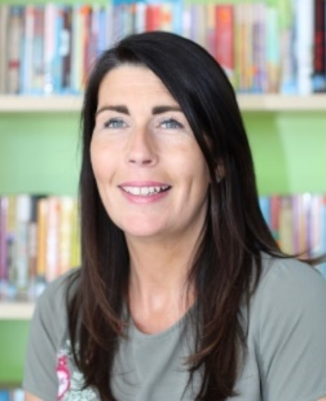

Telephone: 0121 464 2315 Email: enquiry@woodgate.bham.sch.uk
Website: www.woodgateprimary.co.uk Twitter: @woodgateprimary

