How to read with your child at home.

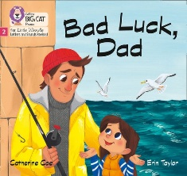
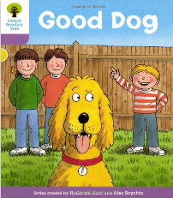
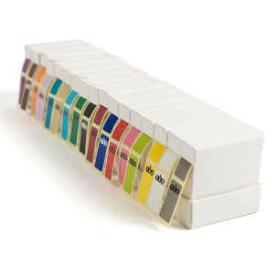
Decodable book- This book is carefully selected by your child’s teacher. It only contains ‘sounds’ they have learnt to read in school.
It usually has a coloured sticker or a phonics phase on the cover.
- Get comfy. Don’t try and read when you’re busy, fed up or distracted. Reading should be fun. Give it your full attention. Find a place where you can sit together comfortably and won’t be disturbed.
- Talk about the cover. Look at the front cover together. Read the title. Who is the author and who is the illustrator? Have you read any books by the same author before? Did you like them? What does the cover picture tell you about the book? Can you guess what it might be about? Lots of decodable books have sounds, tricky words and new vocabulary to read and discuss before you start to read the book. Look at these first. Talk about them with your child.
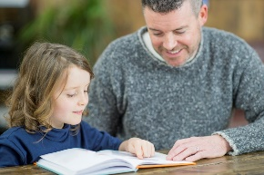
- Listen and encourage. Let the child take the lead, allow them to handle the book and turn the pages. If they struggle with a word, ask them to ‘sound it out.’ If they are still stuck, tell them the word and move on. Smile, nod and praise your child as much as possible.
- Discuss the book as you go. Reading isn’t a passive activity; the reader or listener has to apply their own thinking to what is being read. Don’t see your child’s questions or comments as an interruption; follow their focus and have some book-based conversation.
- Don’t push it! Books don’t have to be read from cover to cover and you haven’t failed if you don’t get all the way to the end in one go. You know your child. Stop when you need to. They are much more likely to want to read again tomorrow if you end on a positive note. Even five minutes of reading will make a huge difference!
- Record it. Write down the pages you read and sign your child’s reading record book. Your child will receive certificates, badges and recognition in school assemblies when they read with you at home. Encourage your child to wear their reading champion badges. Being a good reader is a hugely important skill, be proud that you are supporting your child.
- Keep talking. Remember to talk about books when you aren’t reading – make connections between real life events and books you have read. This helps a child see the value of reading for themselves.
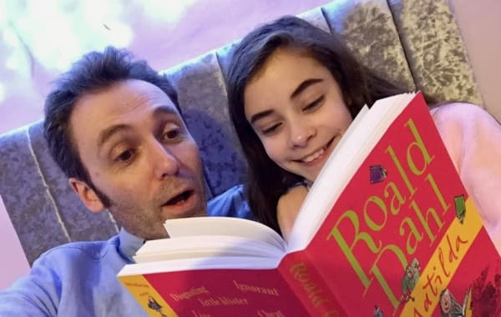
- Read it again. Your child will likely have the same book for at least a week. This is intentional. Read the book several times, as your child become more confident encourage them to add voices and expression.

