How to read with your child at home.

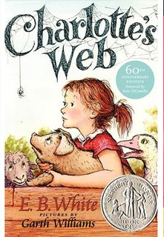

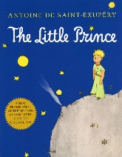
Choice Book- This book is chosen by your child. They may not be able to read it by themselves.
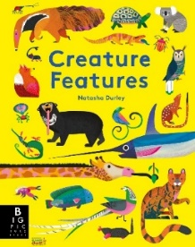
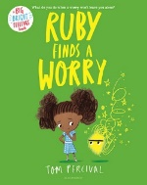
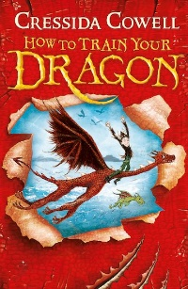
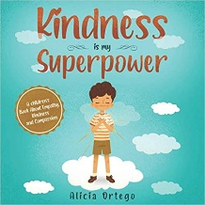
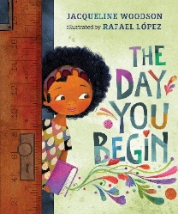
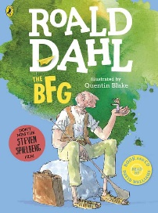
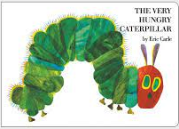
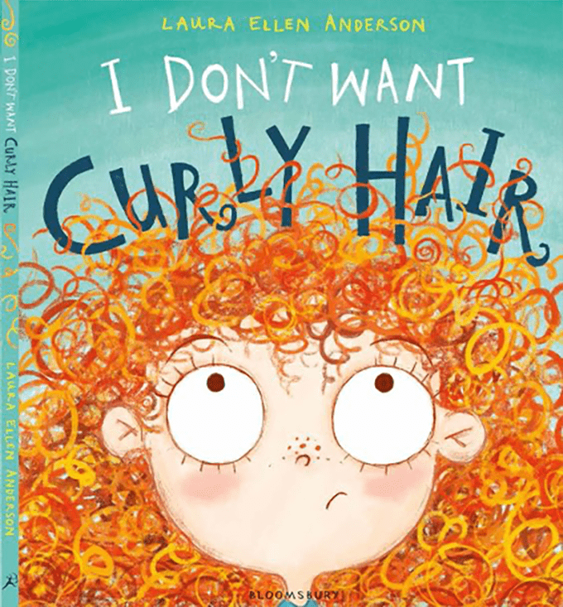

- Get comfy. Don’t try and read when you’re busy, fed up or distracted. Reading should be fun. Give it your full attention. Find a place where you can sit together comfortably and won’t be disturbed.
- Talk about the cover. Look at the front cover together. Read the title. Who is the author and who is the illustrator? Ask your child why they chose the book.
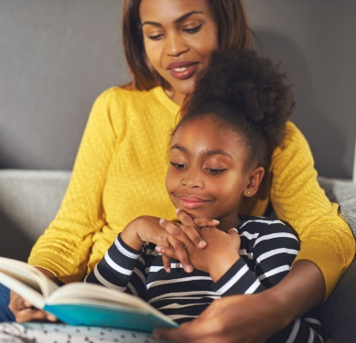
- Decide together. Who is going to read the book? If your child can read most of the book without your help: follow the same advice as the decodable book ‘how to’ guide. If your child can not read the book, read it to them and follow the steps below.
- Use your voice. As you read put as much expression into your voice as possible. Lower your voice, whisper, gasp, shout and make up the voices of the characters. This will help your child understand what you’re reading. Be as fun, silly and creative as you can.
- Discuss the words. If your child can not read the book, there are likely to be words they do not understand. Encourage your child to tell you when they don’t understand a word, stop reading and explain it to them. Using real life examples and putting the word into context really helps. For example-if a child doesn’t understand the word ‘reluctant’ you could say…. “Reluctant is when someone isn’t sure they want to do something. Remember when Daddy was reluctant to go the park yesterday? He was worried it was going to rain, he didn’t want to get wet. He was reluctant.”
- Keep talking. Ask your child what they liked about the book. Tell them what you thought. Can they summarise what you have read in a few sentences? Did they understand what you read? Will they choose a book like this again? Why?
- Record it. Write down the pages you read and sign your child’s reading record book. Your child will receive certificates, badges and recognition in school assemblies when they read with you at home. Encourage your child to wear their reading champion badges. Being a good reader is a hugely important skill, be proud that you are supporting your child.

