1a Read it!
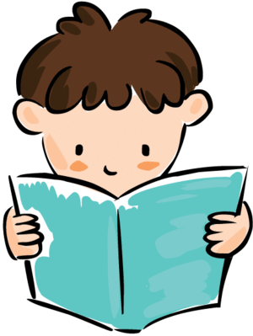

Draw on knowledge of vocabulary to understand texts.
1b Explain it!
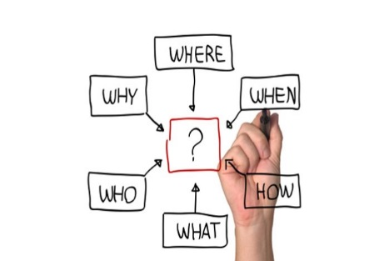
Identify / explain key aspects of fiction and non-fiction texts, such as characters, events, titles and information.
1c Sequence it!
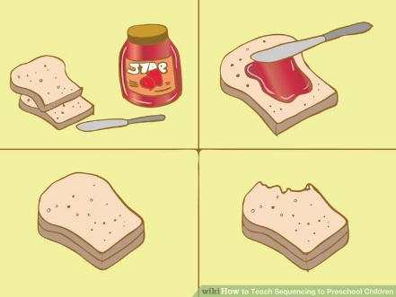

Identify and explain the sequence of events in texts.

1d Think about it!
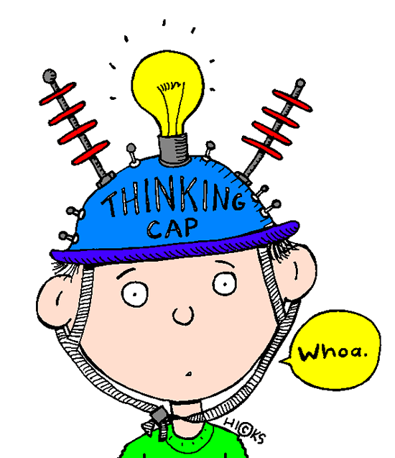
Make inferences from the text.
1e Predict it!


Predict what might happen on the basis of what has been read so far.
2a Explain it!
Give and explain the meaning of words in context.

2b Find and Record it!

Retrieve and record information/ identify key details from fiction and non-fiction.

2c Summarise it!
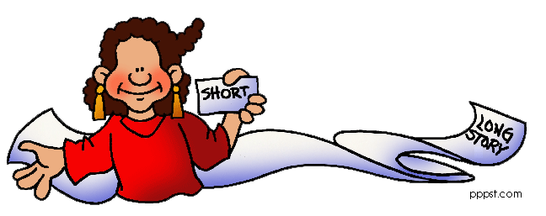

Summarise main ideas from more than one paragraph.
2d Justify it!

Make inferences from the text/ explain and justify inferences with evidence from the text..

2e Predict it!
Predict what might happen from details stated and implied.
2f/2g Explain it!
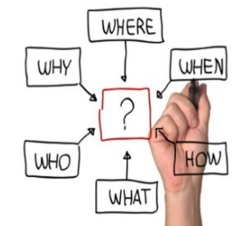
Identify/ explain how information/ narrative content is related and contributes to meaning as a whole/ explain how meaning is enhanced through choice of words and phrases.

2h Compare it!
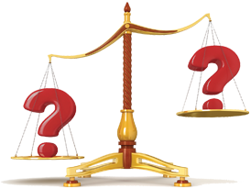
Make comparisons within the text.

