Woodgate Primary School English modules
Year 5
Topic | Greeks |  | National Parks |  | British Empire |  | Mountains |  | Local history |  | Rivers
 | Term 1 |  |  |  | Term 2 |  |  |  | Term 3
Narrative | Greek Myths and Quests  (4 weeks)  Heracles, Perseus and Medusa, Pandora’s Box,  Theseus and The Minotaur etc. |  |  | Diversity Text  (2 weeks)  ‘Found You’  & or  ‘Boy Everywhere’  Book review.  Character, setting & plot studies.  Story maps.    Reflect on main characters or events from different perspectives.  Plan & write narrative.  Plan & write diary recount.  Make a comparison between these similar two books.  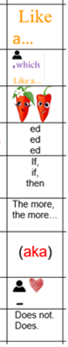    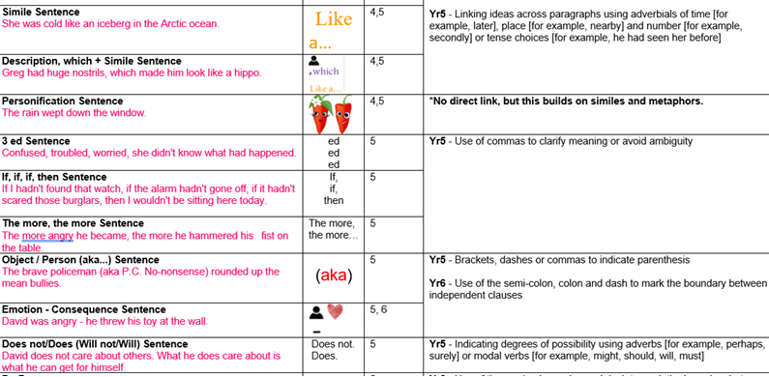    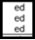 | Author Study  (4 weeks)  J. K. Rowling – Harry Potter & The Philosopher’s Stone  Watch film (visual literacy) |  |  | Diversity Text  (2 weeks)  ‘Precious and The Mystery of Meerkat Hill’  & / or  ‘Me, My Dad & the end of the rainbow.’  Book review.  Character, setting & plot studies.  Story maps.  Reflect on main characters or events from different perspectives.  Plan & write narrative.  Plan & write diary recount.  Make a comparison between these different books. | Fiction from our literary heritage.  (4 weeks)  Shakespeare:  Macbeth (or Romeo & Juliet) |  |  | One short film/ Experiential Learning  (3 weeks)  Read sections of Charles Dickens’ book ‘Oliver’.  Watch film (visual literacy): ‘Oliver Twist’ by Roman Polanski 2005.  End with ‘Oliver!’ Musical 1968.  ***  Film & book review.  Wanted Poster (e.g. for Fagin / Bill Sykes)  Plan & write narrative.  Plan & write diary recount (e.g. as Oliver).  Plan & Write a newspaper report (e.g. about the death of Bill Sykes).  Make a comparison between book, film, musical.  .
Written outcomes | Story maps.  Character, setting & plot studies.  Reflect on main characters or events from different perspectives.  Write Greek myth narrative (focus on characterisation, dialogue and action).  Retelling from different perspective. |  |  |  | Author biography. Comparisons & common themes.  Book review, Character studies.  Write or continue short chapter.  Explanation Text: Mythical Creature  ‘Mythical Zoo’ group presentation |  |  |  | Explore playscript in detail.  Act using playscripts.  Rewrite plot and theme as narrative & / or diary entry.  Complete sections of the story.  Plan and write own playscript.
Non Fiction | Biographies  & Black History  (2 weeks)  Biographies from websites. | Instructions  (2 weeks: playing games, making objects, Greek Pots) |  |  | Journalistic Writing  (2weeks: Everest  + external visitor)  ***  Diary Recount  (1 week: Everest) | Discussion Text  (2 weeks:  Should Humans eat meat?) |  |  | Persuasion  (1 week:  Why BCLM should be World Heritage site) | Explanation  (1 week: How Apollo 11 got to the Moon)
Written outcomes | Research & write biography.  Write informative- newspaper report about key figure.  Black History theme (e.g. Olaudah Equiano & Lenny Henry) | Detailed instructions with a clear introduction and conclusion  (links to DT & PE). |  |  | Recount informative newspaper report about key event  (‘Everest: The Mystery of Mallory & Irvine’).  ***  Recount / diary (climbing Everest) | Present two sides of an argument.  Plan & write a balanced discussion.  Debate. |  |  | Plan & write persuasive argument for target audience  (include BCLM visit & on-line research). | Plan & write explanation text (linked to Geography, History or PSHE).
Poetry | Spoken word /Dub poetry (2 weeks)  ***  Cinquain Poetry (1 week) |  |  |  | Cinquain Poetry  Mother’s Day (1 week) |  |  |  | Take One Poet & their poetry  (2weeks)
Outcomes | Listen to, read, analyse & respond.  Learn & perform poetry.  Write, edit & perform own poem(s).  ***  4 seasons poems for calendar  Poem for Christmas / celebration card |  |  |  | Read, analyse & respond to cinquains.  write own poems. |  |  |  | Explore biography & context.  Explore word play and build vocabulary.  Share, learn, perform poems from same poet.  Write an appreciation of...

Reading Reconsidered Reading Spine.
Archaic Language  - Oliver Twist (Needs abridged version)  - Treasure Island new addition unlabelled & uncovered)  - The jungle | Non-Linear Time Sequences  - A Christmas Carol | Narratively Complex  - Harry Potter & The Philosopher’s Stone  - Sky Song  - Where The Mountain Meets The Moon  - A Series of Unfortunate Events | Figurative/ Symbolic Text  - Sky Song  - Where The Mountain Meets The Moon  - A poem for every night of the year | Resistant texts  - Jabberwocky and Other Nonsense Poems by Lewis Carroll  - ‘Tyger Tyger’ by William Blake
I

