Talk card progression from Year EYFS to Year 6: 

Children should be taught to ‘talk and ‘write’ the sentence types for their year group or ability, but also revisit and recap previously taught cards so that children are using them independently in their writing.

EYFS/ Year 1

Time words  Next, first, then, after. |  | Three ideas.  The man was angry because he was wet, he had no money and his bus had just driven past him. |    | What can you/ they see, hear, smell and feel?  Sarah could smell the mouldy curtains and see the spiders racing across the floor, she heard a floor board creak, now she was really scared. | 
Feeling words  Upset, relieved, happy. Relaxed. |  | Colours  Red, blue, orange. silver. |  | Speech  Who’s that trip trapping across my bridge? | “ ”  “ ”  “ ”  “ ”
Prepositions  Beside, under, below, above | 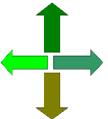 | Size words  Big, gigantic, tiny, miniscule. |  | Use a question  How did you get here so quickly? | How?
Words other than ‘said’.  Replied, shouted, screamed, laughed. |   said | Alliteration  Woodgate wins world welly wangling competition. | a a a | Show not tell  The bush shook and a large padded paw appeared through the dense green foliage. |   
Adverb  This ‘changing shape’ symbol represents an adverb. It modifies the verb or adjective. | 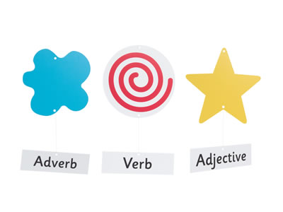 | Adjective  The star represents an adjective. |  | Verb  This ‘swirl’ symbol to represent ‘movement’ acts as a verb.

Sentence type |  | Year Group | Links to National Curriculum
2A Sentence  He was a tall awkward man. | 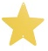  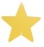  2A | 2 | Yr2 - Expanded noun phrases for description and specification [for example, the blue butterfly, plain flour, the man in the moon]
Double ly ending Sentence  He swam slowly and carefully because his energy was beginning to ebb away. | ly ly | 2 | Yr2 - the use of –ly in Standard English to turn adjectives into adverbs
Verb, person Sentence  Flying, John zoomed away from the evil dragon. |   Verb, | 2 | Yr2 -Use of the progressive form of verbs in the present and past tense to mark actions in progress [for example, she is drumming, he was shouting]
Sound! Clause Sentence  Splat! The water balloon burst as it hit the wall. | ! | 2 | Yr2 - Use of capital letters, full stops, question marks and exclamation marks to demarcate sentences  Commas to separate items in a list
List Sentence  It was a cold, cloudy, wild and windy day. | List  _, _, and__. | 2
Yr2- Subordination (using when, if, that, because) and co-ordination (using or, and, but)
Yr2- Use sentences with different forms in their writing. (exclamations, commands)
Yr3 - Expressing time, place and cause using conjunctions [for example, when, before, after, while, so, because], adverbs [for example, then, next, soon, therefore], or prepositions [for example, before, after, during, in, because of]

BOYS Sentence  He was a friendly man most of the time, but he could become very nasty. | BOYS   | 2,3
What!  What a beautiful day! | What! | 2
How?  How did that happen? | How ? | 2
Command Sentence  Move away from the fire. |  | 2
Then and Now Sentence  Months ago I used to eat meat, but now I am a vegetarian. | Then,  Now. | 3 | Yr3 - Expressing time, place and cause using conjunctions [for example, when, before, after, while, so, because], adverbs [for example, then, next, soon, therefore], or prepositions [for example, before, after, during, in, because of]
With a(n) Action, More Action Sentence  With a smile, Sandy waved goodbye. | 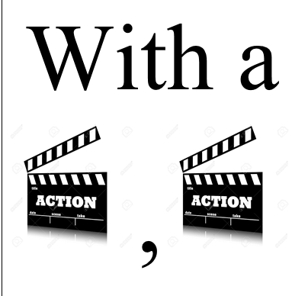 | 3 | Yr3 - Use of the forms a or an according to whether the next word begins with a consonant or a vowel [for example, a rock, an open box]
Short Sentence  Then it happened.  Everything failed.  Oh no! | Short.  Quick.  Fast. | 4 | *No direct link, but this is used to build tension in the plot, in speech between characters or to speak directly to the reader.
Ing, ed Sentence  Driving to town, he stopped to watch the U.F.O land. | Ing,  ed | 4 | Yr4 - Fronted adverbials [for example, Later that day, I heard the bad news.]  Yr4 - Noun phrases expanded by the addition of modifying adjectives, nouns and preposition phrases (e.g. the teacher expanded to: the strict maths teacher with curly hair)  Yr5 - Linking ideas across paragraphs using adverbials of time [for example, later], place [for example, nearby] and number [for example, secondly] or tense choices [for example, he had seen her before]
Emotion word, (comma) Sentence  Desperate, she screamed for help. | 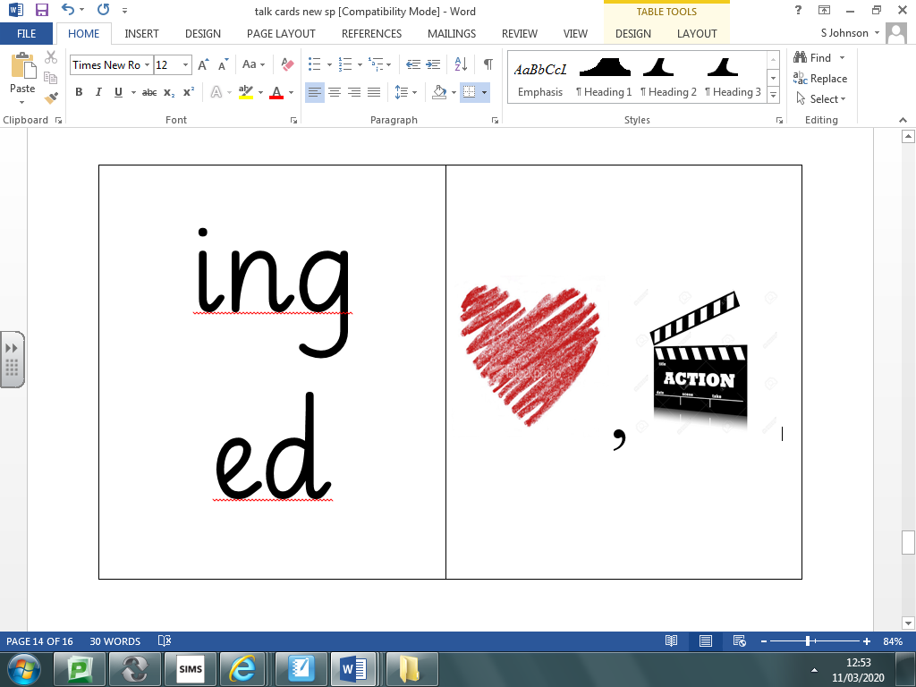 | 4
Simile Sentence  She was cold like an iceberg in the Arctic ocean. | Like  a… | 4,5
Description, which + Simile Sentence  Greg had huge nostrils, which made him look like a hippo. | 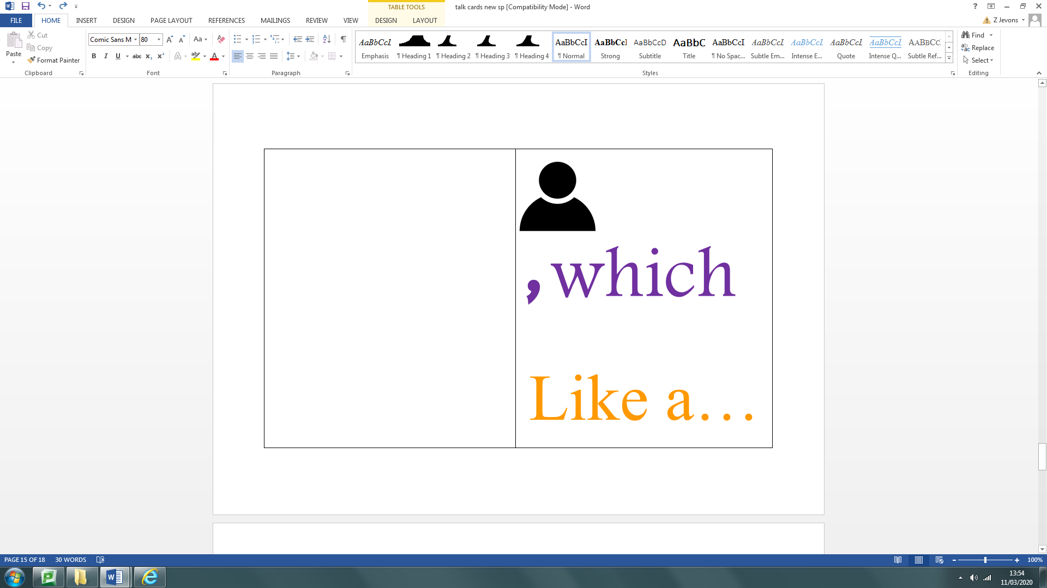 | 4,5
Personification Sentence  The rain wept down the window. |  | 4,5 | *No direct link, but this builds on similes and metaphors.
3 ed Sentence  Confused, troubled, worried, she didn't know what had happened. | ed  ed  ed | 5 | Yr5 - Use of commas to clarify meaning or avoid ambiguity
If, if, if, then Sentence  If I hadn't found that watch, if the alarm hadn't gone off, if it hadn't scared those burglars, then I wouldn't be sitting here today. | If,  if,  then | 5 | Yr5 - Use of commas to clarify meaning or avoid ambiguity
The more, the more Sentence  The more angry he became, the more he hammered his fist on the table. | The more,  the more… | 5 | Yr5 - Use of commas to clarify meaning or avoid ambiguity
Object / Person (aka...) Sentence  The brave policeman (aka P.C. No-nonsense) rounded up the mean bullies. | (aka) | 5 | Yr5 - Brackets, dashes or commas to indicate parenthesis  Yr6 - Use of the semi-colon, colon and dash to mark the boundary between independent clauses
Emotion - Consequence Sentence  David was angry - he threw his toy at the wall. | 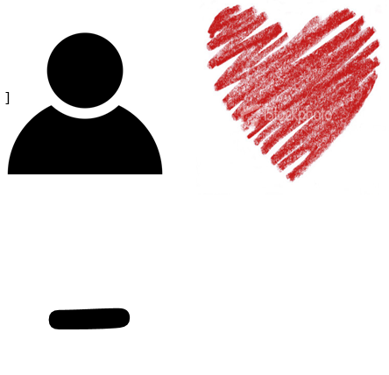 | 5, 6
Does not/Does (Will not/Will) Sentence  David does not care about others. What he does care about is what he can get for himself. | Does not.  Does. | 5 | Yr5 - Indicating degrees of possibility using adverbs [for example, perhaps, surely] or modal verbs [for example, might, should, will, must]
De;De  The vampire is a dreadful creature; it kills by sucking all the blood from its victims. | De;De | 6 | Yr6 - Use of the semi-colon, colon and dash to mark the boundary between independent clauses [for example, It’s raining; I’m fed up]  Use of the colon to introduce a list and use of semi-colons within lists
Some; others Sentence  Some people can't stand football; others love it. | Some;  others… | 6
The Question Is: Sentence  Jordan disappeared. The question is: where did he go? | The question is…? | 6
Outside (Inside) Sentence  He smiled and shook the man’s hand warmly. (Inside, however, he was angrier than he had ever been.) | Outside  (Inside) | 6 | Yr6 - Linking ideas across paragraphs using a wider range of cohesive devices: repetition of a word or phrase, grammatical connections [for example, the use of adverbials such as on the other hand, in contrast, or as a consequence], and ellipsis
So ... Sentence  He had never felt so ... odd. | so… | 6
Broken Sentence  The princess was delighted. Absolutely. Positively. Delighted! | 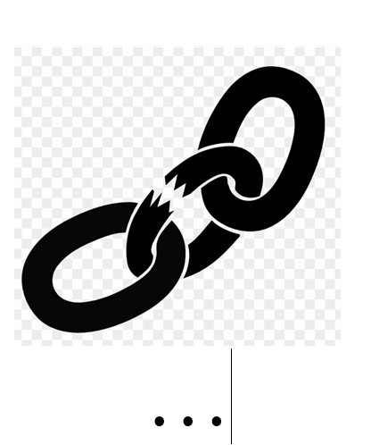 | 6

