How to support your child’s writing at home.

- Read every day. That’s right…READ every day. Reading and writing are so interlinked that every time you read with your child you’re also helping them become better writers, communicators and thinkers.

- Exercise. If you have very young children, a child that complains their hand hurts when writing, or struggles to form letters; consider their finger strength. Some children do not have the muscle tone or hand eye co-ordination to write. There are lots of things you can do to help. Playing with playdough, jigsaws, threading, painting, drawing and cutting all help your child learn the skills they need to become successful writers.

- Be a good role model. You do not need to be a fantastic writer, but be aware of the basics when writing with your child.

- Capital letter at the beginning of each sentence and a full stop at the end.
- Don’t mix capital letters into words, they are for the start of sentences and names (people/places) only.
- A finger space between each word.
e.g. I am going to the shop to buy some milk. $√$
i am GoinG to the shop to buY some milk. X
- Sound out any words you can’t spell.

- Re-read your sentence to check it make sense.

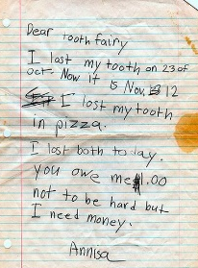
- Give writing a purpose.
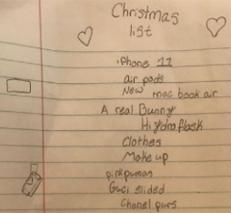
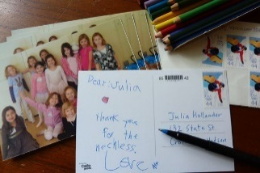
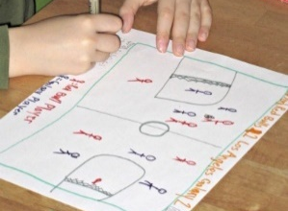
Give your child as many opportunities to write as you can. When children write for a purpose they see the value of writing and learn that words have meaning. When you make a shopping list, write a birthday card, respond to an email, write a text to a friend … show your child. Let them help. If they see how useful the skill of writing is, they are much more likely to do it.

- Don’t put them off!
Don’t rush them.
Don’t ask a child to write without talking and thinking together first.

Don’t look over your child’s shoulder all the time and criticise.

Don’t stop to correct errors immediately; give them time to get their ideas down.
Don’t forget to read what they have written and say well done.

