How to help your child start to write.

1.Read every day. That’s right…READ every day. Reading and writing are so interlinked that every time you read with your child you’re also helping them become better writers, communicators and thinkers. Tracking your finger along the words as you read, teaches your child that we read and write from left to right. Do you have lots of books at home? If not, speak to your child’s class teacher, we will happily provide you with some from our reading shed stock (free of charge).
2.Talk! There are many skills a child needs before they can even begin to write. The most important skill is communication. If a child cannot speak in sentences, talk about the things they see around them …how can they write about it? If a child doesn’t hear an adult describing things and explaining things… how will they ever learn all of the words they need to become good writers. Talking and listening allows us to make links in our brain between what we see and feel, to the words we need to become writers. Ask your child questions about their day, their interest and their friends. Discuss the things you see around you as you walk home or drive to Nan’s house. It is scientifically proven that children who speak and are spoken too regularly become better readers, writers and mathematicians!
Look at the huge, black bird flying high in the sky! Where do you think he is going?
3.Are they ready to write? Before children begin to write, they need the fine motor skills to hold a pencil and track from left to right. They need time to learn these skills. There are lots of things you can do at home to help your child be ready to write. Provide them with different pens so they can feel them and make marks on paper. Did you know that drawing is a very early form of writing? When a child draws they learn how to grip a pen, how much pressure to apply and how to control their hand. Cutting, threading, playing with playdough and sorting small coins, pegs or beads helps your child develope the muscles they need to begin to write.
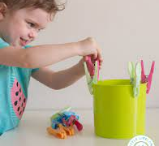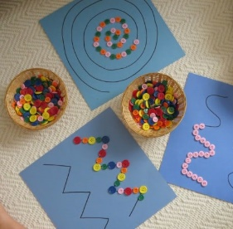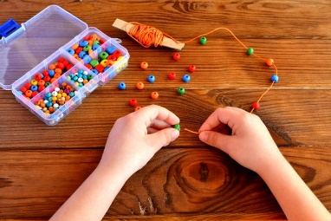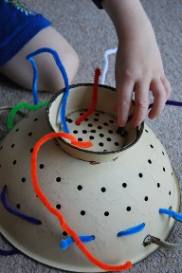
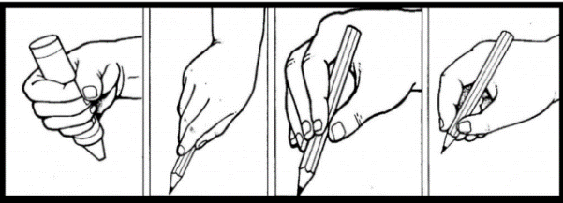
4.How to hold a pencil. As your child’s hand strength improves, support them to hold their pencil in the correct way. Most children learn to hold a pencil in stages, as shown in this picture. Don’t force your child to hold their pencil in a way they find uncomfortable. If your child is left handed they may develop a slightly different grip that is suitable for them.
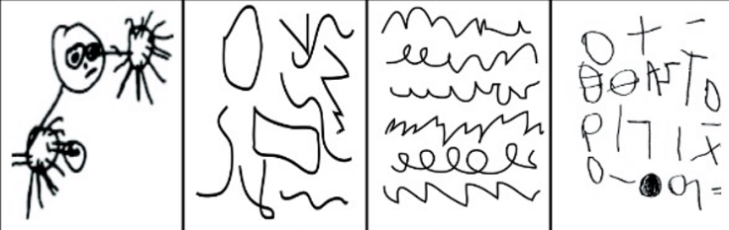
5.Praise their attempts. Children need to learn that the marks they make have meaning. If your child attempts to write (even if it looks like scribbles) praise them and ask them to read what they have written. It might not look like words to you, but to them it is their attempt to communicate through letters and words. This is their early writing and the first, crucial steps on the journey to becoming a fluent writer.

